Amanda Wang
Art History 1B
Professor Nemerov
TA: Maria Terss
On the Temporary State of Human Existence
Seven men, a boisterous array of string instruments, Jesus descending from the cross, and Plato walk into a small room. It is “Musical Party in a Picture Gallery,” a late 17th century painting created in Flanders by an unknown artist. On the seven gentlemen present: three are playing string instruments, two are holding sheet music, and the leftmost gentleman is motioning to those beyond the painting’s frame in a very inviting way, almost as if to say, “Please, come join us.”
Most striking and unusual about the painting at first glance, however, is the gallery of paintings that surround the men. Without the gallery wall that surrounds, the lavish nature of the room and its inhabitants may simply seem to be an honest depiction of the Flemish aristocracy during this time period. However, when looking into the subject matter of the gallery paintings, and seeing how they both interact with and connect to the subjects, the tone and meaning behind the piece shift dramatically.
This essay argues that this painting is not simply a comment on the aristocracy, but a comment on the temporary nature of human existence, especially when compared to an eternal lifetime of heaven or hell under God’s discretion. It is a reminder that no matter how lavish of a life one lives as human, that this state is destined to change. More importantly, that piety and dedication to God must continue to be taken with the utmost urgency and importance if any sense of joy is to remain throughout eternity.
This analysis begins by looking at the painting in its most basic form. As the title states, it is a musical party in a picture gallery. Dutch portrayals of musical parties became quite common in the 17th century, as “singing and playing stringed instruments was a form of socializing among members of polite society” throughout Europe. The most popular depiction of music in paintings during this period was entitled ‘Vanitas Still-Life,’ in which “music is at best a waste of precious time, at worst an occasion for sin.” This genre originated at the University of Leyden, a Calvinist stronghold, and focused on evoking contemplation in the viewer.
One example worth contrasting to “Musical Party in a Picture Gallery” is “A Musical Party” by Gabriël Metsu, that currently resides in the Metropolitan Museum of Art. In Metsu’s painting, there are four figures: a male and female each holding a string instrument, and two servants. The aristocratic woman passes a book of music back to one of the maids, while the other maid stops in the doorway at the back of the scene, holding refreshments for the two practicing musicians.
The attire in both Metsu’s “A Musical Party” and “Musical Party in a Picture Gallery” represent traditional dress in Europe during this time, another indication of wealth: ornate details on bright-colored fabric, ruffles, hand-sewn shoulder caps, and beautifully embroidered gowns for the woman and two-piece sets for the men. Furthermore, the two paintings could be claimed similar for the presence of overindulgence and temptation in both. Looking at Metsu, this can be seen in the foot-warmer that resides underneath the aristocratic woman’s foot and the carelessness with which she barely clutches her lute, almost as if she is not concerned if it falls because she will just purchase a new one.
In “Musical Party in a Picture Gallery,” the decorative vases, uneaten lobster on the table, and the high and elaborately decorated ceilings indicate a similar overindulgence and temptation. While this initial analysis may seem to indicate similar messages behind each painting—that of an overindulgent aristocratic social class in Flanders during this time period—“Musical Party in a Picture Gallery” is unique in that once one deeply analyzes the serious, religious connotations present in the picture gallery, it becomes clear that the paintings’ meanings are entirely different.
Now that the physically present subjects of “Musical Party in a Picture Gallery” have been analyzed in isolation, an in-depth look at the picture gallery and how the characters interact both with each other and the paintings behind them will reveal a greater truth about how temporary human existence is. Those present in the painting, and those who are literally painted on the walls, are no different in the eyes of God. After all, what has become of those present in the painting? To us, the viewer, they are simply another painting.
The largest painting to a viewer seems to be the upper leftmost painting, in which there are two young females. The female in a pink tunic is paying attention to a dove, perched on her right arm, which has historically served as a symbol for the Holy Spirit. What draws viewers to this painting specifically, then, is the parallel positions of the leftmost gentleman dressed in all black and this female—although mirrored images of one another, their hands extend outwards.
While the young female is paying her attention to the Holy Spirit, the gentleman looks outwards and at an upwards angle, perhaps pointing viewers to take their eyes off of him and look to the upper left-hand corner of the larger painting. This is no small coincidence given that the greatest source of light emanates from this corner, both inside of the painting as well as the way that the light in Cantor touches the painting. Although the gentleman may initially be interpreted as inviting guests into the room, given the comparison to the painting above him, it seems more likely that he is inviting the viewer to admire God, the ultimate provider of light and eternal happiness.
Furthering on the way that light is used in this painting, despite the overall darkness of the paintings hung behind the main subjects, the one source of light is Jesus’ body. The scene is Jesus’ descent from the cross, as Mary clutches him in despair, as is shown in 15th century Dutch painter Rogier van der Weyden’s The Descent from the Cross. Although no cross is shown in the painting of Christ, the coat hanger in the middle of the room not only points us upwards to the image of Christ, but literally represents the cross from which Christ has been taken off.
The wooden coat hanger, then, brings Christ into the human world and reminds the room that He died and made the ultimate sacrifice so that humanity could live the lives they currently do. Under that logic, a higher quality of life should only mean a higher level of devoutness towards Christ. This includes every single person in the room, and every single person that views this painting. Furthermore, despite this wooden hanger standing tall in the center of the room, none of the men are looking at it. They are all too focused on enjoying the sensations that they are creating and that exist in this singular moment of their human existence.
Delving deeper into these sensations, this painting is extremely vivid in how it triggers viewers’ senses. The way the instrument’s music fills the room with sound; the pungent smell of lobster and wine on the small coffee-table; the feeling of touching one of the instruments or sheet music; even the feeling of such nice shoes rubbing against the hard, tiled floor. The artist seems very intentional in making the reminders to worship and stay pious via the gallery paintings purposefully subtle, embedded through the larger painting full of such sensory activation. This is to say that getting to heaven isn’t meant to be easy; there will be an overwhelming amount of temptation in the human experience, and it is up to the individual to overcome it. That is the true test of someone worthy for eternal light and heaven.
It is no coincidence, then, that behind the table with the lobster and drink, there are four identical gold-embedded, red chairs all lined up beside one another. Reminiscent of a waiting room in a hospital, these seats may represent judgment by God. No matter your status in the human world, all will be evaluated identically and objectively. The presence of multiple such judgment chairs seems to group the fate of the four men on the right of the painting together; the four extremely focused on perfecting the playing of their instruments.
Apart from the more striking and blatantly religious gallery paintings present, it is also worth noting that the other paintings on the gallery wall are intentional in their content. One such striking painting is the still life of flowers in a vase shown on the righthand wall. It shows flowers at different stages of their lives, replicating the cyclical nature of human existence: drooping white flowers hanging off of the right of the vase, those emerging into their peak bloom towards the top, and those just beginning to wilt right at the tip of the vase.
Similarly, another painting not focused on human life is the winter landscape on the middle-right side. Many branches are covered in white, as others fall to the ground; there is a small slit of light and sunshine beyond the clouds in the far background, potentially pointing to summer, another season. The deep reds and oranges that color the houses seem to indicate autumn. Overall, the representation of many seasons, cycling and transitioning smoothly from one to the next, is yet another reinforcing comment on the cyclicality of existence in this human world.
One of the easiest paintings to overlook, yet hard to ignore once noticed, is the portrait of Platos’ face in the very top right corner. He seems to be staring at and addressing the viewer with wide, confrontational eyes. Although Plato is often cited as one of the greatest influencers of Western religion and Christianity, his placement in this painting seems to hold a different, much more significant meaning than one of being devout. His “Allegory of the Cave” puts forth two different types of people. The first are those who believe that knowledge comes from our sensational experiences–what we see and hear in the world. These are the people trapped in a cave of misunderstanding and foolishness. Plato views those who rely on their senses as weak and fragile, because this image of human existence is merely a shadow of reality. The second type are those who see through the un-trustworthiness of the senses. These people use their own intellect to push the boundaries and recognize that human life is not a realm in which humans can or will obtain knowledge of ‘true reality’.
Taking these ideals forth to “Musical Party in a Picture Gallery,” Plato’s outlook becomes an exact parallel for the artist’s argument on how temporary human existence is, and really strengthens the artist’s purpose and argument. The artist is intentional to support his own argument with that of one of the greatest and well-respected minds of all time. Plato would mock the men for their naïve sense of joy and happiness. However lovely the sound of the music, delicious the taste of wine and lobster, visually appealing the paintings that surround them, it is simply a shadow of true reality for each of the men present.
The last component necessary to fully flesh out and support the argument that this painting emphasizes living a devout life over one of temporary indulgence, it is important to next look at why the artist would create such a piece. This analysis begins with an understanding of the historical context of the period during which it was created. The 17th century was an extremely tumultuous time in Europe, especially for religion and the Catholic Church. The Protestant Reformation was the largest challenge to the Catholic Church, and led to the first, truly segmented Europe, untied by a single religious faith. In response to the Protestant Reformation, the Catholic Church launched a counter-reformation, and most notably, created the Council of Trent in order to create internal reforms.
“Musical Party in a Picture Gallery” was created just two years after the Council of Trent ended. Still under the rule of Spanish archdukes Albert and Isabella, Flanders became an extremely attractive place for religious congregations to settle, and Catholicism remained the dominant religion. However, internal dissent still remained in Flanders. As was common throughout the rest of Europe at this time, art was a great form of propaganda. Although it is unclear where this painting was placed, due to its lavish subjects and larger size, it was most probably commissioned by a wealthy family, who may have even hung the painting up in their music room. As music existed as such a social activity, it is likely that many higher-class people in Flanders viewed this painting. Understanding the meaning makes this fact almost satirical now.
The artist’s sheer creation of this painting categorizes him as far above the vast majority of people that Plato would deem foolish. Knowing who his audience is takes this intelligence and thoughtfulness one step farther. The artist mocks the viewers of this painting by creating an illusion to the simple eye that this is just another sensational treat; another beautiful painting for them to gaze upon and create notions of fake happiness upon. However, behind the curtain, this hidden message is only clear to those who have the eyes to see it; those who can identify Plato and his thought; fundamentally, those who attempt to understand life beyond the shadowed reality of human existence.
The one figure present in the painting who seems to understand these complex ideals is also the only man who enters viewer’s space, making direct eye contact at each and every individual who passes this painting. He is the only figure present who seems to pass the inevitable test of virtue. He is the one holding the music, and therefore, conducts the men playing music. His stance is confident, and the slightly tilted-down angle of his face addresses the viewer in almost a condescending way. He is saying, ‘I am the conductor of this musical gathering, as well as the knowledge that this human life is temporary. I will do my part to honor religion, will you?’ It seems that he is placed into this scene as encouragement for the viewer, enforcing the notion that although difficult, it is possible to resist temptation and gain a spot in eternal light. Furthermore, in the same way that the men are reflected by the paintings that surround them, this man is the viewer’s mirror image. His curious, borderline judgmental stare is a reminder that viewers, too, cannot be complacent. He has the power of foresight; the understanding that the experiences he has right now are temporary. This grants him the power to really enter our space.
All in all, this painting is as timeless today as was Plato’s “Allegory of the Cave” in the 17th century when this painting was created. As viewers observe this painting inside the Cantor – itself, a lush gallery room full of other paintings – a sense of shared experiences is created. Just as viewers of this painting so immediately and intimately relate to a group of unknown figures, this painting is exceptional in that it boils down to a simple question: what do you believe in? However complex the answer to this question may seem, it is a deceivingly simple one in the eyes of the artist, and God: you are either conscious of the temporariness of human existence, or you are not.

Bibliography
Evennett, H. O. "THE COUNCIL OF TRENT." Blackfriars 41, no. 482 (1960): 198-206.
www.jstor.org/stable/43816002.

Leppert, Richard D. "Concert in a House: Musical Iconography and Musical Thought." Early
Music 7, no. 1 (1979): 3-17. www.jstor.org/stable/3126378.

Luce, J. V. "PLATO'S RELIGIOUS EXPERIENCE." Hermathena, no. 96 (1962): 73-91.
www.jstor.org/stable/23039533.

Metsu, Gabriël. 1659. “A Musical Party.” Oil on canvas, Dimensions 24 ½ in. x 21 3/8 in. New York, Metropolitan Museum of Art. Accessed November 10th, 2019. https://www.metmuseum.org/art/collection/search/437070.

Plato. “The Allegory of the Cave.” Republic, VII. https://web.stanford.edu/class/ihum40/cave.pdf

van de Vate, Esther. Maria Peyt: A Carmelite Mystic in Wartime: 22-31. Brill, 2015.
https://searchworks.stanford.edu/articles/edsbeb__edsbeb.B9789004291874.004.

van der Weyden, Rogier. Before 1443. “The Descent from the Cross.” Oil on panel. Stanford,
CA, Professor Nemerov Art History 1B Lecture. Shown September 25th, 2019.

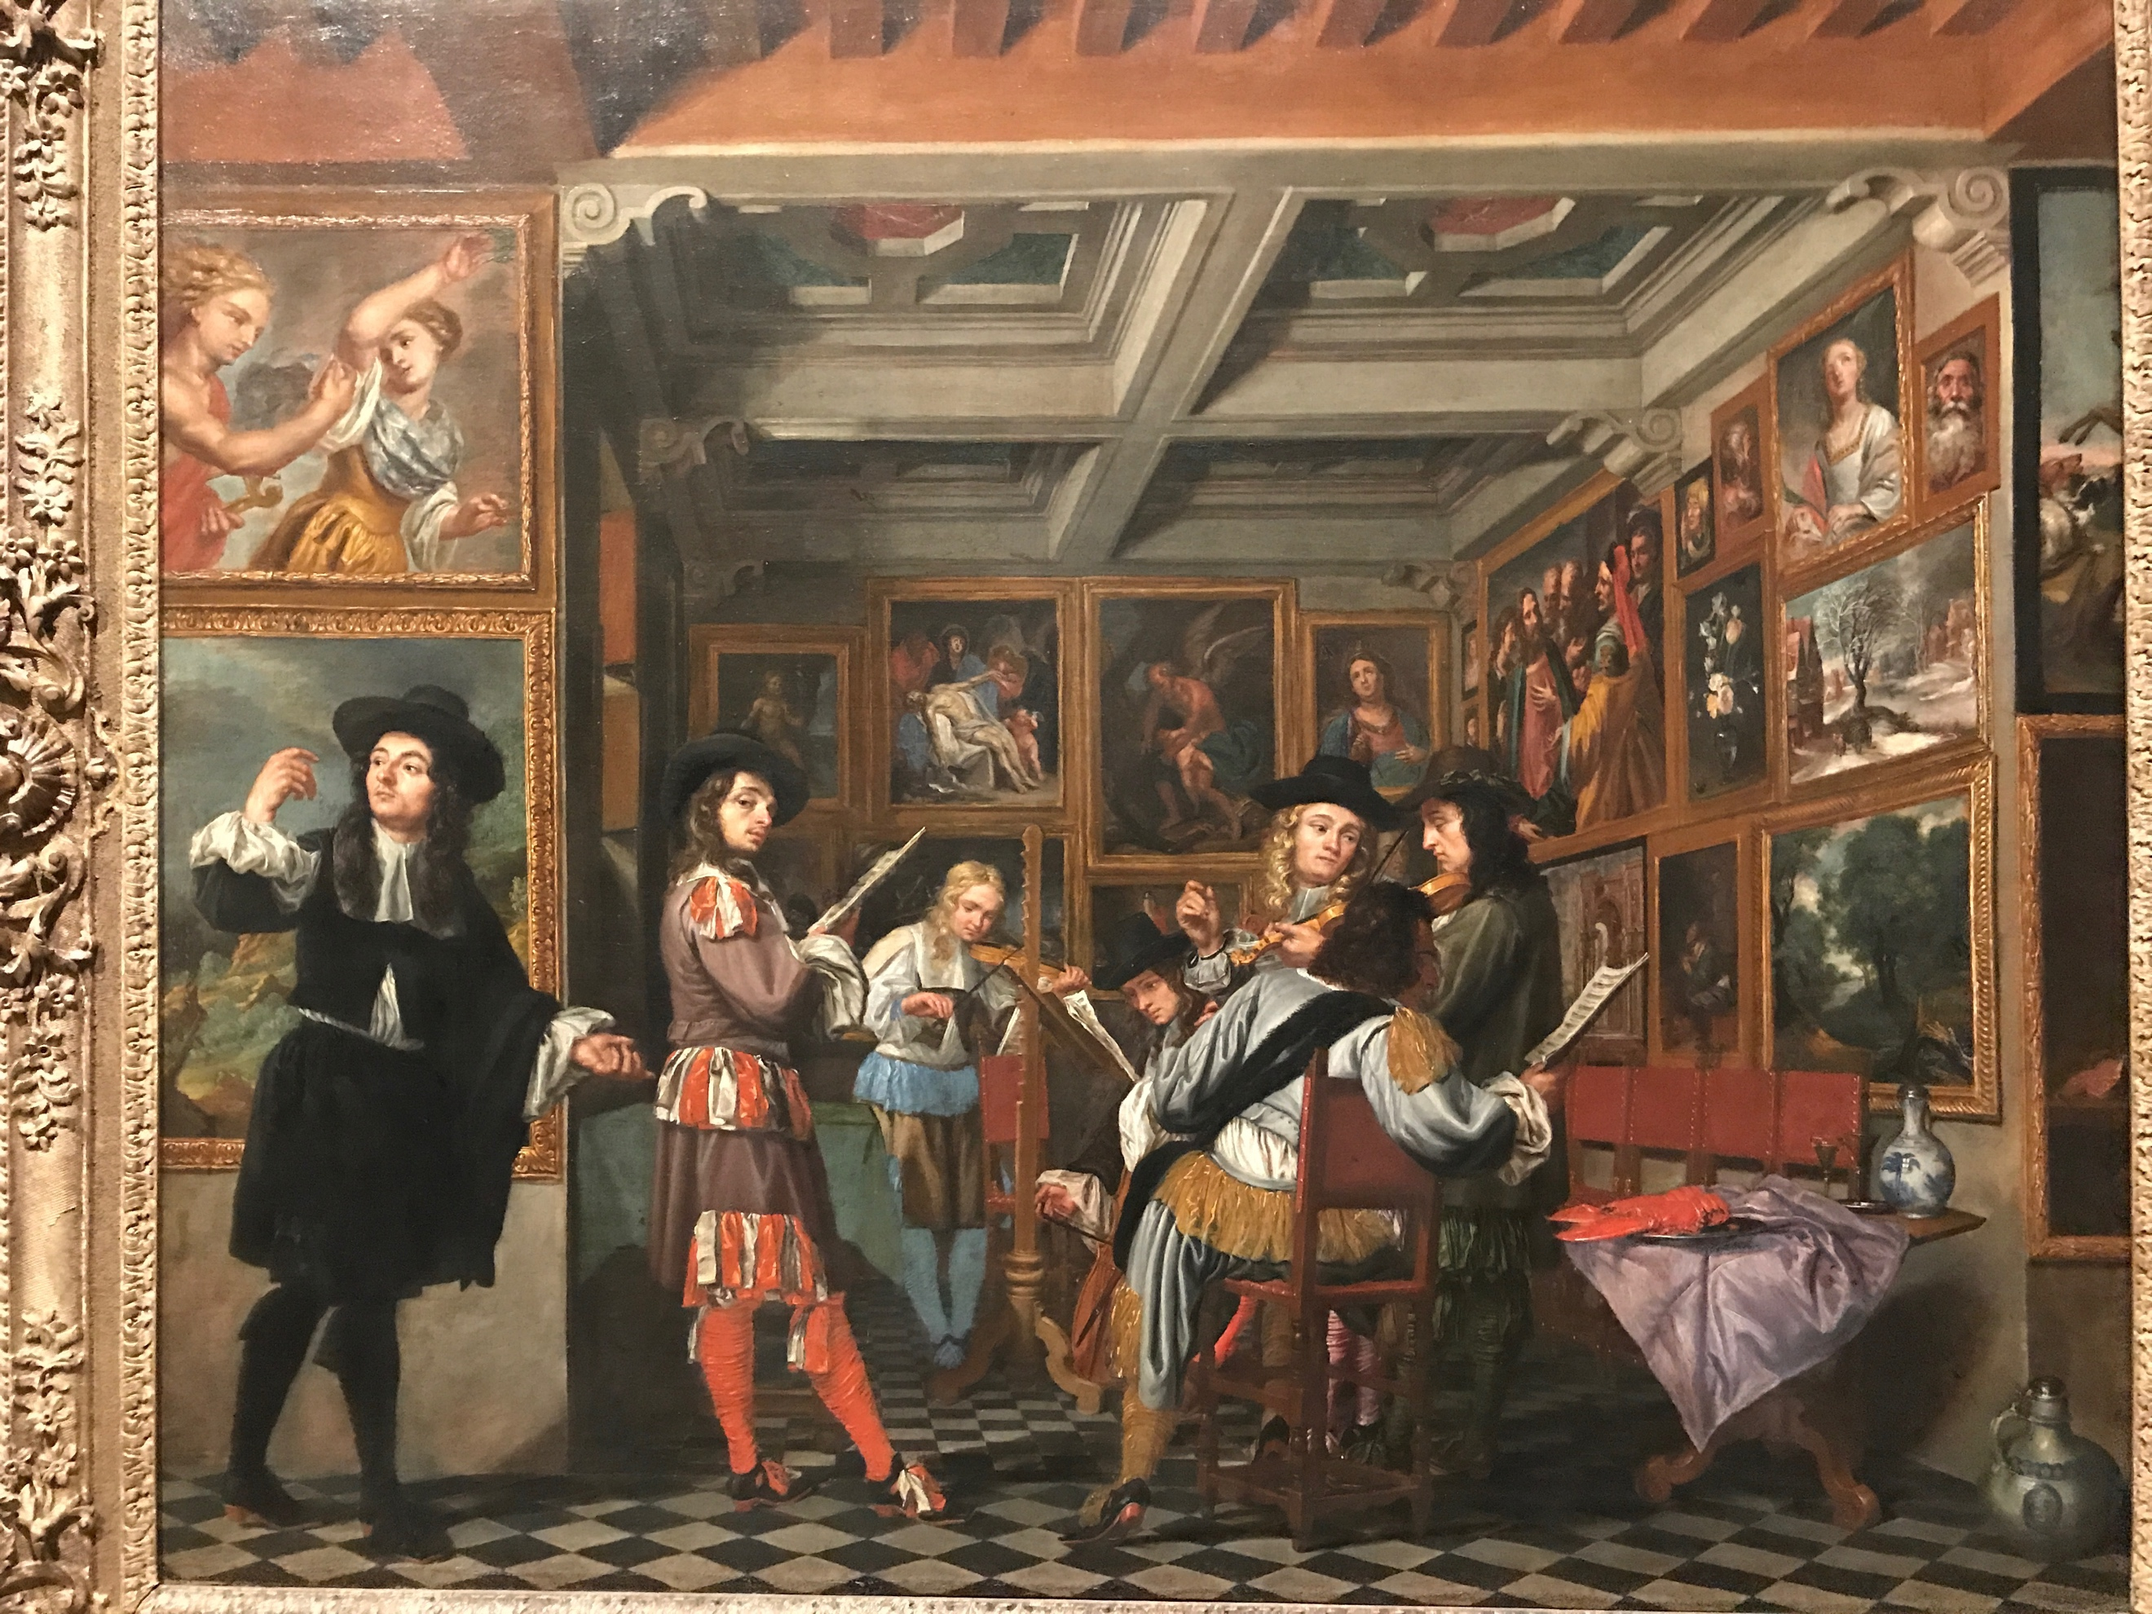
Unknown artist. Musical Party in a Picture Gallery, late 17th century, oil on canvas, Stanford, CA, Cantor Arts Collection.

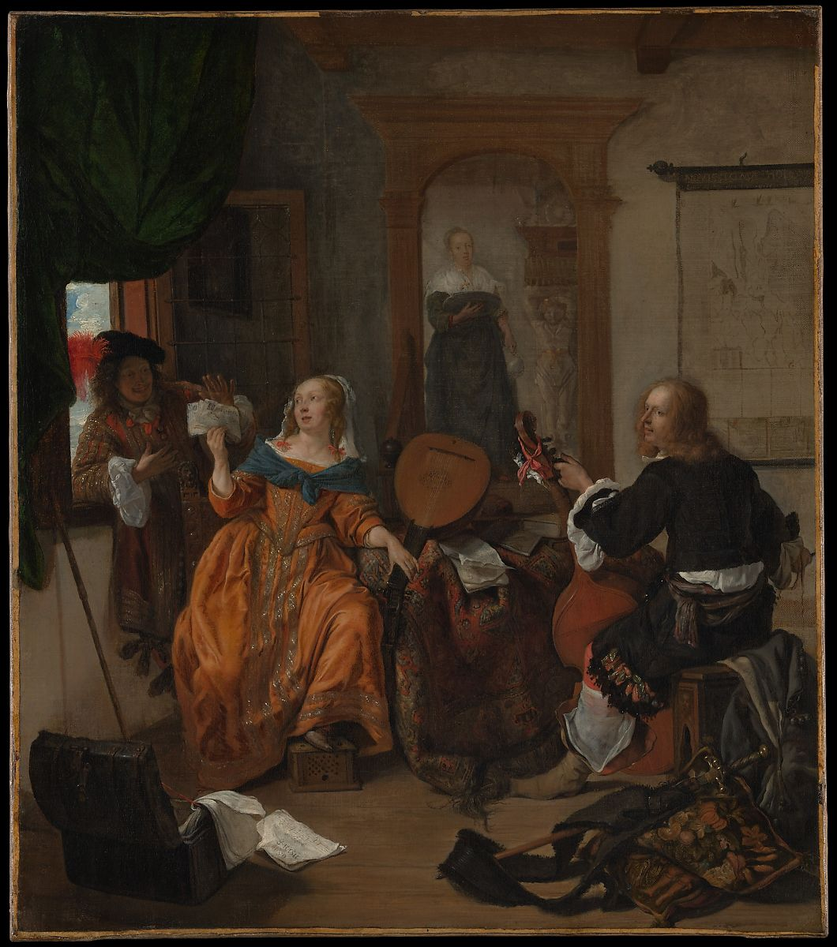
(Plate 1) Metsu, Gabriël. A Musical Party, 1659, oil on canvas, New York, NY, The Metropolitan Museum of Art.

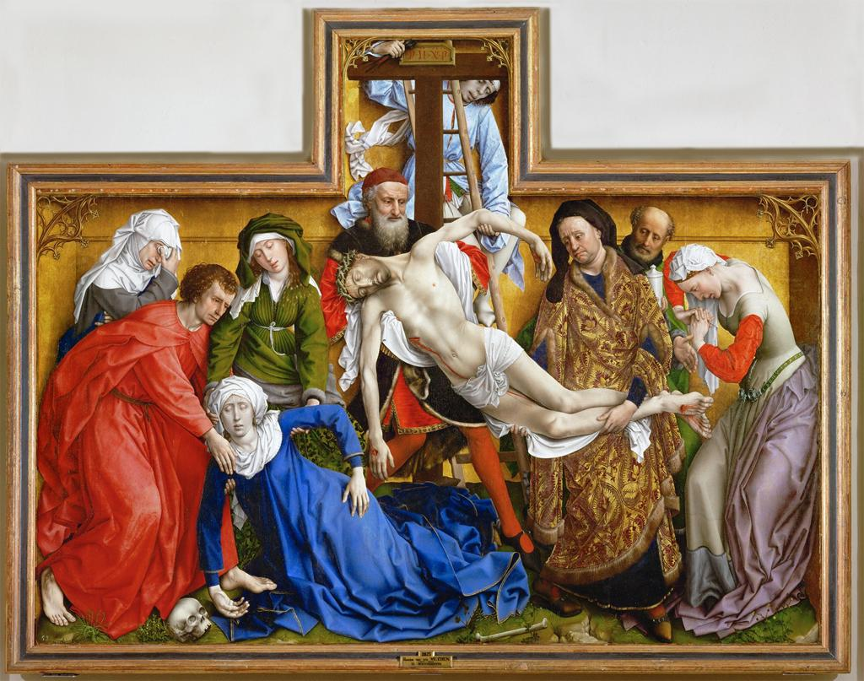
(Plate 2). van der Weyden, Rogier, before 1443, oil on panel, Madrid, Spain, Museo Nacional del Prado.

(Plate 1) Gabriel Mëtsu, “A Musical Party,” 1659, (Metropolitan Museum of Art, New York, NY).
Richard D. Leppert, Concert in a House: Musical Iconography and Musical Thought, (Oxford University Press, Jan. 1979), 11.
Ibid., 11-12.
Mëtsu, “A Musical Party.”
(Plate 2) Rogier van der Weyden, “The Descent from the Cross,” 1443.
Plato. “The Allegory of the Cave.” Republic, VII.
H.O. Evennett, “The Council of Trent," (Blackfriars 41, no. 482, 1960), 200.
Richard D. Leppert, Concert in a House: Musical Iconography and Musical Thought, (Oxford University Press, Jan. 1979), 11.

