Chapter I
Democracy and its mathematical discontents

1.1 Choosing an Electoral System

The last thirty years saw a worldwide movement towards democratic governance. This triggered a renewed search for effective methods of ensuring representative government. Of the world's 211 countries, 36 are “established democracies” according to the criteria of Lijphart. There are 77 democratic countries according to scales used by Blais & Massicotte. What distinguishes one democracy from another—apart from the particular form and history through which popular representation appeared—is the way its electoral system functions.

An electoral system is the method by which votes in national elections translate into seats in a Parliament or Lower House. This system may have emerged through a quirk of history, or through the impact of colonialism, or the influence of neighbors, by way of evolution, or through violent revolution, but it exerts a powerful influence on the political future and cohesion of a nation.

Three interdependent elements constitute democracy: political rights, civil rights and institutionalized checks and balances. Political rights comprise free speech and freedom for political participation. Civil rights protect people from practices such as unreasonable searches and seizures, slavery, and torture. Institutionalized checks and balances give citizens the right to limit the powers of the state. According to the maxim of Aristotle, to be "civilized" is to be "political": "Man is by nature a political animal". By this statement, Aristotle meant the obligation of civilized man to participate in the political affairs of the city. The 14th century historian Ibn Khaldun considered this statement of Aristotle the cornerstone of society. It is interesting to note that the ancient Arabic translation of this statement does not include the word "animal", and simply reads, "Man is civic by nature".

Elections are the cornerstone of democracy. To quote Riker, "[T]he essential democratic institution is the ballot box and all goes with it." Huntington defines "a twentieth-century political system as democratic to the extent that its most powerful decision-makers are selected through fair, honest, and periodic elections in which candidates freely compete for votes and in which virtually all the adult population is eligible to vote." This is a minimal definition of democracy. The electoral system chosen by a country dictates the rules of the game under which that country’s democracy is practiced.

How are votes in a national election translated into seats in a parliament? And what constitutes "fairness"? Hundreds of electoral systems are currently used in the world, and, potentially, one can devise thousands more. They all fall into three broad families according to the way in which they aggregate votes:

- Plurality-Majority systems (P-M);
- Semi-Proportional Representation systems (semi-PR) ; and
- Proportional Representation systems (PR).

The following flowchart offers a summary of all systems.

Plurality and Majority systems are both winner-take all schemes; they differ in the number of representatives per district. PR reflects the proportions of votes received by competing parties as closely as possible. Semi-PR systems are a mix of both.
Electoral System Families
Proportional Representation
(e.g. Germany, Brazil, Chile, New Zealand)

Semi-PR
(e.g. Japan, Jordan)
Plurality-Majority
(e.g. U.S., France, Mali, Palestine, Egypt)
While political scientists agree on the three categories, they sometimes disagree on how to classify particular countries. Table 1.1 shows that among the 208 countries and territories listed in the 2002 International Institute for Democracy and Electoral Assistance (IDEA) database, 76 countries have adopted PR, 73 chose plurality rule, 30 chose majority rule, while 21 countries opted for semi-PR. Eight countries (including Saudi Arabia, Libya and China) cannot be classified. Countries with a British colonial legacy—such as Canada, India, and the United States of America—tend to use a plurality system. While there is a strong correlation between colonial background and the adoption of a specific electoral system, this is not universally the case. Former French colonies are not prone to adopt the majority rule which France has known for most of its history. Plurality is more common in North America, Africa, and Oceania. PR is more prevalent in Europe and South America. Countries struggling for a compromise between the “old” and the “new” tend to choose “semi-PR” electoral formulas.
Table 1.1. Breakdown of Electoral Systems Worldwide (2002)

System | Number of countries | % of countries
Plurality | 73 | 35
Majority | 30 | 14
PR | 76 | 37
Semi-PR | 21 | 15
Other | 8 | 4
Total | 208 | 100

The effect of different electoral systems is a matter of debate. The effect of plurality-majority systems is generally to exclude extremist and fringe groups from parliament, unless the extremists are geographically concentrated. Critics have argued that plurality-majority systems also tend to exclude minorities and women from "fair" representation. For example, in the U.S., African Americans comprised 12.3 % of the population at the last census. However, in the House of Representatives, which is elected by a PM system, they comprise only 9.0 %. The situation is worse for Hispanics, women and other minorities; compare Table 1.2 and Table 1.3. In the 2000 census, 12.6 % of the U.S. population reported being “Hispanic or Latino”; however, only 7.4 % of representatives in the House are Hispanic. Neither African Americans nor Hispanics currently have any representation in the Senate.
While women represent about 51 % of the U.S. population, only 14.3 % of the House is currently women and 13 % of the Senate. Non-minority men compose about 78 % of the representatives in the House, while non-minority women represent 8 %.

Table 1.2. Members of Congress (1981-2003)

Member of congress and year | Male | Female | Black | Hispanic | Other
REPRESENTATIVES
97th Cong. 1981 | 416 | 19 | 18 | 6 | 3
98th Cong. 1983 | 413 | 21 | 21 | 8 | 3
99th Cong. 1985 | 412 | 22 | 21 | 10 | 3
100th Cong. 1987 | 412 | 23 | 23 | 11 | 4
101st Cong. 1989 | 408 | 25 | 24 | 10 | 5
102nd Cong. 1991 | 407 | 28 | 26 | 11 | 3
103rd Cong. 1993 | 388 | 47 | 38 | 17 | 4
104th Cong. 1995 | 388 | 47 | 40 | 17 | 4
106th Cong. 1999 | 379 | 56 | 39 | (NA) | (NA)
107th Cong. 2001 | 374 | 61 | 36 | 19 | 5
108th Cong. 2003 | 373 | 62 | 39 | 25 | 7
SENATORS
97th Cong. 1981 | 98 | 2 | - | - | 3
98th Cong. 1983 | 98 | 2 | - | - | 2
99th Cong. 1985 | 98 | 2 | - | - | 2
100th Cong. 1987 | 98 | 2 | - | - | 2
101st Cong. 1989 | 98 | 2 | - | - | 2
102nd Cong. 1991 | 98 | 2 | - | - | 2
103rd Cong. 1993 | 98 | 2 | - | - | 2
104th Cong. 1995 | 93 | 7 | 1 | - | 2
105th Cong. 1997 | 92 | 8 | 1 | - | 2
106th Cong. 1999 | 91 | 9 | - | (NA) | (NA)
107th Cong. 2001 | 87 | 13 | - | - | -
108th Cong. 2003 | 87 | 13 | - | - | 3

Data from across the world suggests women tend to be less represented in countries that use plurality-majority systems than in those with PR. The 1995 “Women in Parliament” annual study commissioned by the Inter-Parliamentary Union found that women made up to 11 % of the parliamentarians in established democracies using a particular form of plurality, but the figure is almost 20 % in countries using PR. This pattern of increased representation of women with PR is observed in emerging democracies, especially in Africa. Table 1.4 shows the average representation of women around the world in both lower and upper houses of parliament countries as of January 2004. Under PR, women’s representation in the lower house is, on average, about 18 %, in comparison to the 11-12 % figures under plurality or majority. Ranked by the percentage of women, the U.S. was 17th out of the 61 countries using plurality which were studied; the highest Rwanda with 48.8 % of women representation, and lowest being Kuwait and Korea with 0 %. Under the majority electoral formula, the highest was reported in Cuba (36%), followed by Vietnam (27.3 %); Australia ranked fourth with 25.3 %, while France was 9th (12.2 %). Egypt appeared at the bottom of the majority systems when it comes to women’s representation (2.4 %).

Table 1.3. U.S. Population by Race and Sex, 1800-2000

Census Data | Total ** | White | Black | Other | Sex Ratio *
1790 | 3,929 | 3,172 | 757 | - | 103.8
1800 | 5,308 | 4,306 | 1,002 | - | 104.0
1810 | 7,240 | 5,862 | 1,378 | - | 104.0
1820 | 9,639 | 7,867 | 1,772 | - | 103.3
1830 | 12,866 | 10,537 | 2,329 | - | 103.1
1840 | 17,070 | 14,196 | 2,874 | - | 103.7
1850 | 23,192 | 19,533 | 3,639 | - | 104.3
1860 | 31,443 | 26,923 | 4,442 | 79 | 104.7
1870 | 39,819 | 33,589 | 4,880 | 89 | 102.2
1880 | 50,156 | 43,403 | 6,581 | 172 | 103.6
1890 | 62,948 | 55,101 | 7,489 | 358 | 105.0
1900 | 75,994 | 66,809 | 8,834 | 351 | 104.4
1910 | 91,972 | 81,732 | 9,828 | 413 | 106.0
1920 | 106,711 | 94,821 | 10,463 | 427 | 104.0
1930 | 122,755 | 110,287 | 11,891 | 597 | 102.5
1940 | 131,669 | 118,215 | 12,866 | 589 | 100.7
1950 | 150,697 | 134,942 | 15,042 | 713 | 98.6
1960 | 179,823 | 158,832 | 18,872 | 1,620 | 97.1
1970 | 203,302 | 178,098 | 22,580 | 2,883 | 94.8
1980 | 226,546 | 194,713 | 26,683 | 5,150 | 94.5
1990 | 248,710 | 208,704 | 30,483 | 9,523 | 95.1
2000 | 281,422 | 211,460 | 34,658 | 35,304 | 96.3
* Males per 100 females
** in Thousands
Source: Dictionary of American History

Under PR, things are dramatically different. Scandinavian countries lead the way with figures as high as 45.3% in Sweden; the lowest were recorded in Turkey (4.4 %) and Madagascar (3.8%).

China contributed the bulk of the average appearing in Table 1.4 for countries which do not use the three electoral methods described, with 20.2 %. The others were Libya, with no data on women’s representation, Saudi Arabia and United Arab Emirates with no representation of women.

Table 1.4. Representation of Women Worldwide (2004)

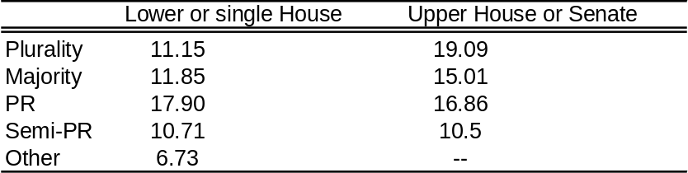

EXERCISES

- If the 435 seats of the U.S. House of Representatives were allocated according to the ethnic/racial divisions in the 2000 in Table 1.3, how many seats would each group get? What difficulties do you see? How would you resolve them?

- The 435 seats in the U.S. House of Representatives were divided according to the gender breakdown in the U.S. population in 2000 (see Table 1.3), how many seats would go to women?

- (a) Repeat Exercise1 to allocate the 100 seats in the U.S. Senate along ethnic/racial lines.
(b) Repeat Exercise 2 to allocate the Senate seats according to gender.

- In 1814, the Stortinget, Norway’s national assembly, was formed at Eidsvoll. Of the 112 representatives, 25 represented the towns, 33 represented the army and navy, and 54 represented the rural districts. Norway’s first census was carried out in 1769; the population then was 723,618. In 1822 the population reached one million. For the purposes of this problem, assume the number of representatives in the Stortinget reflected the population distribution of Norway at the time.

  - Estimate upper and lower bounds for the proportions and numbers of urban and rural Norwegians in 1769.
  - Estimate the combined size of the Norwegian army and navy in 1769.

- Broken down by occupation, the Norwegian Stortinget of 1814 included 37 landowning farmers, 13 merchants, 5 industrialists and 57 government officials. Assuming the Stortinget was representative of occupation, how large are the corresponding groups in the population? Is it likely that this assembly was representative?

- Convicted felons are not allowed to vote in several states. Recently, the list used by Florida election officials to remove the names of felons from their voting roles was recently challenged. About 8 % of Florida voters identify themselves as Hispanic, while 11% identify as African-American. Of nearly 48,000 felons on the list used by Florida officials—and thus scheduled to be removed from the list of eligible voters—61 were found to be Hispanic while 22,000 were African-Americans. Hispanic Republicans in the state outnumber Hispanic Democrats by 100,000, while 90 percent of Florida’s 1,000,000 Black voters are Democrats.

    - Assuming the proportions of felons reflected those of voters, how many Hispanic and how many African-American felons would you expect?
    - Assuming that the same proportions of African-American felons are Republican and Democratic as of African-American voters, how many African-American Republicans and how many African-American Democrats were on the list used by Florida officials?
    - How many Hispanic voters are there in Florida?
    - What percentage of the Hispanic voters are Republican?
    - Assuming the same percentage of Hispanic felons are Republican as of Hispanic voters, how many Hispanic Republicans and how many Hispanic Democrats were on the list used by Florida officials?
    - Find the total number of Hispanic and African-American Republicans on the list. Find the total number of Hispanic and African-American Democrats on the list.
    - Comment on the challenge to the list. What would have been the effect of using it?

- Confirm the numbers in Table 1.1. Using “filter” or “countif” on the file world-voting-systems.xls, filter into five categories: PR, Semi-PR, Plurality, Majority, Other, and calculate the percentages of each. The first category (PR) has been filtered for you. (Instructions for these commands are in filtering-data.doc.)

- To see how see women’s participation varies under different electoral systems, fill in the following table:

Average Percentage of Women in National Parliaments

 | Lower or single House | Upper House or Senate
Plurality
Majority
PR
Semi-PR
Other

Do this using the data in the women-in-parliament.xls file:
  - Filter into the five categories: PR, Semi-PR, Plurality, Majority, Other. (Instructions for the “filter” command are in filtering-data.doc.)
  - Calculate the percentage of women in the Lower and Upper Houses of Parliament in each category.
  - What do you conclude from the numbers in the table?
  - For countries using the plurality system, which country had the largest percentage of women, and what was the percentage? Which had the smallest? How did the US rank?
  - For countries using the majority system, which country had the largest percentage of women, and what was the percentage? Which had the smallest?
  - For countries using PR, which country had the largest percentage of women, and what was the percentage? Which had the smallest?

- South Africa uses a “closed” party list form of proportional representation (PR). Half of the parliament seats (200 seats) are filled by candidates elected from nine regional lists, while the other 200 are filled from national lists. We will focus on South Africa’s April 2004 Elections. The results are given in the file south-africa.xls. Since we do not have access to separate regional and national data, we will assume seats and votes distributions came from a single cumulative contest which does not distinguish the two.

- Calculate the percent of votes garnered by each party.
- Calculate the percents of seats won by each party.
- Calculate the number seats to which each party is entitled, allowing decimals. Think of some sensible way of distributing the fractional parts.
- If all the parties that did not receive a seat in the South African parliament ran as a coalition, to how many seats would they be entitled?
- According to the census of 2001, South Africa’s population was 44.8 million; 79 % (35.4 million) identified as blacks, 9.6 % (4.3 million) were whites, four million are mixed-race and around one million Asians. How many seats would each ethnic group hold in South Africa’s parliament under PR?

1.2 Apportionment Schemes

In a federal system, proportional representation means a given state or canton receives a proportion of seats in the government commensurate with its population. For example, in the U.S., PR determines the number of seats each state has in the House. In a PR-system such as in most European countries, proportional representation means each party contesting in a national election receives a number of representatives according to the votes receives. Mathematically, these two problems (calculating the number of seats or calculating the number of representatives) are the same. Apportionment problems of the same nature appear in many instances. A country wants to see how many divisions from each state it ought to mobilize to form an army with a prescribed size that is representative of its regions. A person dies and leaves cattle or property to be distributed fairly among his or her inheritors.

The central problem of PR is how to convert votes to seats. In its simplest form, the solution is to assign a fraction of seats equal to that party’s fraction of the votes. However the devil is in the details: how to assign the fractions of seat. This question is surprisingly difficult, and over the last 200 years has lead to a variety of methods, each with advantages and disadvantages. They fall in one of two categories:

- Largest Remainder methods (LR), also called Quota Methods.
- Divisor methods (D).

A summary description of eleven methods is illustrated in Table 1.5 (p. 17). It includes both European and American names for the schemes.

Largest Remainder Methods

The oldest and most natural method was first devised by British barrister Hare almost 150 years ago. Balinski & Young attribute the method to Hamilton, one of the American “founding fathers”. The methods in this category work by calculating a ‘quota’ representing the number of voters per seat, or the population per representative, so

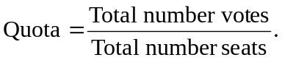

Ideally, the seats would be apportioned according to

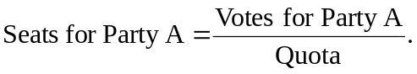
Of course, the number of seats assigned to Party A by this formula is likely to be a fraction. In Hare’s method, each party first gets the whole number of seats assigned to it by this formula. The unassigned seats are then distributed to the largest remainders first, until they are exhausted. You might feel this method is so straightforward that it must be the only one necessary. Chapter 4 shows, however, that this method leads to some surprising and undesirable consequences, which have led to the development of other methods. Two others, the Droop and Imperiali Methods, are similar to the Hare Method; the others are quite different.

Divisor Methods

Divisor methods are also known as “highest average” schemes. The eight most commonly used systems are described in Table 1.5; the most straightforward is the d’Hondt method. The best intuition as to how these methods work was offered by Michael Gallagher. Each party competes for each seat in a sequence of bids as if at an auction. To see how this system works, we consider the d’Hondt method with three parties. Suppose we arrange the votes in decreasing order:

Votes A | Votes B | Votes C.

Party A gets the first seat because it has the largest number of votes. To determine who gets the next seat, we divide each of the number of votes by 2 and compare

 | Votes B | Votes C
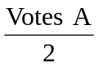 | 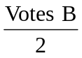 | 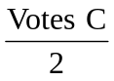,

where Votes A is omitted because it has been “used up” since Party A got the first seat. Now there are two possibilities: Votes B is the largest (in which case Party B gets the next seat), or 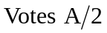 is largest (in which case Party A gets the second seat). To decide about the third seat, add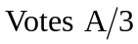, 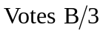, and so on, to the table and omit the entry that led to the second seat and proceed. This is done until all seats have been exhausted.

The divisor methods differ in the sequence of divisors they employ. For example, the Huntington method used in the US to determine size of the Electoral College uses the divisors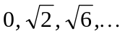. The oldest methods go back to Belgian Professor d’Hondt and the French Mathematician A. Sainte-Laguë.

1.3 The Mathematical Problem: Measuring Injustice

Throughout these notes, whenever we refer to a party system, P₁, P₂, …, P_{N}, will denote the respective votes obtained by N parties contesting for seats in a national parliament. By s₁, s₂, …, s_{N}, we will denote the corresponding seats that these votes translate into. By P and S, we will designate the total number of votes and the total number of seats. Whenever we refer to a federal system, P₁, P₂, …, P_{N}, will denote the population of the N states in the federation, and s₁, s₂, … , s_{N} will be the number of representatives from each state. Then P and S are the total population of the country and the total number of representatives in its parliament, respectively. For bicameral systems, this is usually the lower house. We will carry our analysis for party systems. We have

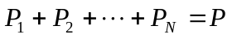,
and
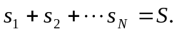

If the sequence of votes is such that:
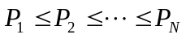,

we expect the sequence of seats to satisfy:

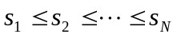.

In an ideal apportionment, the following should occur:
- For a given party i, the fraction of votes is equal to the fraction of seats: 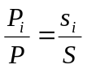;
- The relative fraction of votes between two parties i and j is equal to the relative fraction of seats: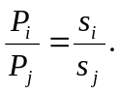
However, the chance of either (a) or (b) to occur all at once for all parties in a given election is almost zero. In practice, one attempts to make the difference between the left hand side and right hand side of either (a) or (b) as small as possible for all parties, or all pairs of parties.

Two numbers a and b can be compared using either their absolute difference 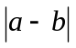or their relative difference 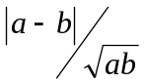 If we use absolute differences, we attempt to:

- Minimize the 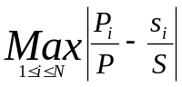 in the case of (a).

- Minimize the 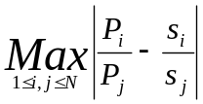 in the case of (b).

In an ideal apportionment, both these minima will be zero. In practice, these minima are not zero, and their values give a measure of the injustice of the apportionment. The larger the minimum value obtained, the less fair the apportionment.

Alternatively, using relative differences, in the case of (b), we would minimize
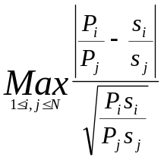.

In an ideal apportionment, this minimum will be zero. In practice, its value is a measure of injustice. Deciding which measure of injustice to minimize leads to different electoral systems.

Another measure of injustice is given by the following argument. Dividing the S seats among the N parties gives the following exact proportions:

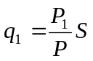, 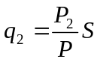, …, 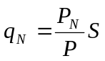.

Summing all these exact proportions gives S:

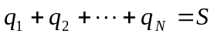.

In an ideal apportionment where all the q_{i}’s are integers,

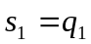, 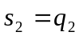, …, 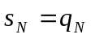.

In practice, the q_{i} are not whole numbers. In a proportional apportionment, the party should get either 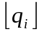 or +1 seats (here 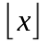 denotes the result from rounding x down to the nearest integer). These are called, respectively, the Hare minimum and Hare maximum for that given party. The fractions left in assigning seats are

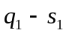, 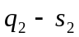, …, 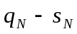.

Since each party should ideally get a number of seats number of seats equal to either its Hare minimum or its Hare maximum, these errors are either positive or negative fractions between 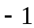 and 1. The sum of all these errors is zero:

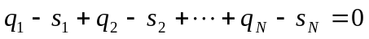.

Thus,

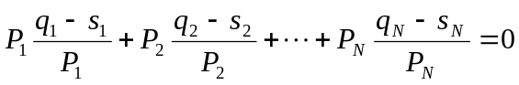,

Since by the definition the q_{i}s,
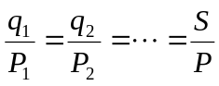,
we have

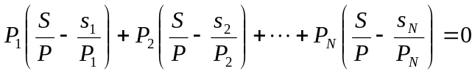.

Approximating the ideal case, we attempt to minimize the following weighted error:

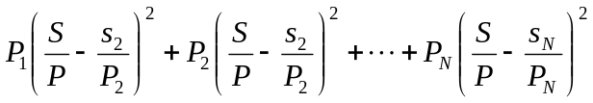.

We could also drop the weights, namely the votes for each party, and minimize the standard error:

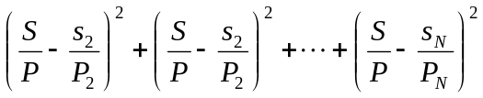.

In fact, the methods we will describe in the following chapters stem from these interpretations as to what constitutes a measure of injustice. Other interpretations lead to more complications which will be addressed later.

For the purposes of illustration, we will use three of the four measures of error described above:

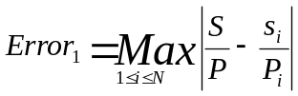

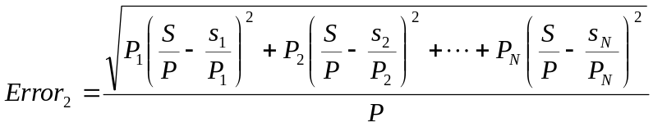

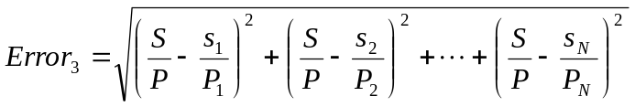

In these definitions, Error₂ and Error₃ are scaled relative errors, while Error₁ is an absolute error. None of these errors have units. A seat allocation under one system is better than another one if the error it generates is smaller.

Let us illustrate these measures by looking at the Antigua and Barbuda Legislative Elections of March 23, 2004. The House of Representatives of these Caribbean Islands is composed of 17 seats. However, in the last elections, one seat remained undecided. The actual distribution of the remaining 16 seats was decided using a majority system; the results are listed in the third column of Table 1.5. Alternative seat distributions, calculated using proportional representation, are in the fourth, fifth columns, and sixth columns termed “Alternative 1”, “Alternative 2”, and “Alternative 3”. We have used the Excel file injustice.xls to calculate the three proposed error measures for the Antigua and Barbuda example.

Table 1.5. Antigua & Barbuda Legislative Elections, March 23, 2004

Party | Votes | Seats | Alternative 1 | Alternative 2 | Alternative 3
United Progressive Party | 21,892 | 12 | 10 | 9 | 8
Antigua Labour Party | 16,544 | 4 | 4 | 7 | 6
Barbuda People's Movement | 492 | 0 | 1 | 0 | 1
Others | 791 | 0 | 1 | 0 | 1
Undecided Seat |  | 1 | 1 | 1 | 1

The calculations are summarized in Table 1.6. The current distribution of seats is better than “Alternative 1” and “Alternative 3” if Error₁ is our measure of what constitutes a “fair” election. “Alternative 2” is obtained under the Hare scheme discussed earlier. It constitutes the best seat allocation if Error₂ is the measure of a fair election. It is also the best alternative if Error₃ is the measure of fairness.

Table 1.6. Antigua & Barbuda Injustice Measures

 | Current Distribution | Alternative 1 | Alternative 2 | Alternative 3
Error₁ | 4.03x10⁻⁴ | 1.63x10⁻³ | 4.04x10⁻⁴ | 1.63x10⁻³
Error₂ | 8.35x10⁻⁷ | 1.23x10⁻⁶ | 3.70x10⁻⁷ | 1.11x10⁻⁶
Error₃ | 6.11x10⁻⁴ | 1.85x10⁻³ | 5.70x10⁻⁴ | 1.84x10⁻³

1.4 Assumptions

In this section, we list some of the underlying assumptions for a “reasonable” apportionment. In a perfect proportional scheme:

- No party should lose seats if the total number of seats is increased.
- Each party should stay within one seat of its quota q_{i,} that is 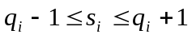.
- A large party should not be favored at the expense of a small party artificially or vice-versa.

In a federal system, two additional assumptions are required:

- No state should lose a representative as a result of the addition of a new state to the union, provided the total number of seats increases.
- Each state should have at least one representative.

EXERCISES

- Consider the results of the 1999 Legislative Elections in Antigua & Barbuda provided in the table below. Use the file injustice.xls to answer the following:

Party | Votes | Seats | Alternative 1 | Alternative 2 | Alternative 3
United Progressive Party | 14,713 | 4 | 12 | 8 | 6
Antigua Labour Party | 17,521 | 12 | 4 | 9 | 8
Barbuda People's Movement | 418 | 1 | 1 | 0 | 2
Others | 445 | 0 | 0 | 0 | 1

  - Which alternative is best if Error₁ is the measure of fairness?
  - Which alternative is best if Error₂ is the measure of fairness?
  - Which alternative is best if Error₃ is the measure of fairness?

- Consider the results of the 2002 Legislative Elections in Pakistan provided below. The seats were allocated using the “First Past The Post” plurality system. The alternatives 1 & 2 were produced using two versions of proportional representation which will be discussed in chapters 2 & 3. Use the file injustice.xls to answer the following.

  - Which alternative is best if Error₁ is the measure of fairness?
  - Which alternative is best if Error₂ is the measure of fairness?
  - Which alternative is best if Error₃ is the measure of fairness?
  - Is the current distribution of seats in Pakistan the “fairest”?

Party | Votes | Seats | Alternative 1 | Alternative 2
Awami National Party | 307,255 | - | 2 | 3
Baluchistan National Party | 69,177 | 1 | 0 | 1
Jamhoori Watan Party | 96,277 | 1 | 0 | 1
Mohajir Quami Movement | 918,555 | 13 | 8 | 8
Muttahida Majilis-e-Amal | 3,349,436 | 53 | 31 | 31
National Alliance | 1,363,814 | 12 | 13 | 12
Awami Tehrik | 204,349 | 1 | 1 | 2
Democratic Party | 83,925 | 1 | 0 | 1
Muslim League (Functional) | 328,137 | 4 | 3 | 3
Muslim League (Junejo) | 212,749 | 2 | 2 | 2
Muslim League (Nawaz) | 2,790,747 | 19 | 26 | 26
Muslim League (Quaid-e-Azam) | 7,612,411 | 69 | 72 | 70
Muslim League (Ziau-ul-Huq) | 87,394 | 1 | 0 | 1
People's Party Parliamentarians | 7,632,708 | 71 | 72 | 70
People's Party (Sherpao) | 98,638 | 2 | 0 | 1
Tehreek-e-Insaf | 229,125 | 1 | 2 | 2
Independents | 4,187,015 | 21 | 40 | 38

- Consider the following distribution of seats for the Pakistani Parliament obtained using proportional representation using the 2002 election results.

Party | Votes | Seats
Awami National Party | 307,255 | 3
Baluchistan National Party | 69,177 | 1
Jamhoori Watan Party | 96,277 | 1
Mohajir Quami Movement | 918,555 | 8
Muttahida Majilis-e-Amal | 3,349,436 | 31
National Alliance | 1,363,814 | 12
Awami Tehrik | 204,349 | 2
Democratic Party | 83,925 | 1
Muslim League (Functional) | 328,137 | 3
Muslim League (Junejo) | 212,749 | 2
Muslim League (Nawaz) | 2,790,747 | 26
Muslim League (Quaid-e-Azam) | 7,612,411 | 70
Muslim League (Ziau-ul-Huq) | 87,394 | 1
People's Party Parliamentarians | 7,632,708 | 70
People's Party (Sherpao) | 98,638 | 1
Tehreek-e-Insaf | 229,125 | 2
Independents | 4,187,015 | 38
- Calculate the natural quota of each party, q_{i}.
- Calculate the error, q_{i}-s_{i,} committed in assigning the seats to each party.
- Calculate the total sum of errors. What do you observe?

- Consider the apportionment of S seats between N parties. Let P₁, P₂, …, P_{N} denote the number of votes each party obtained; q₁, q₂, …, q_{N}, denote the exact portions of the parties and s₁, s₂, …, s_{N}, the number of seats each party garnered. The total number of votes is denoted by P.
  - Using the formula for q_{i}, show that 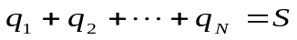.
  - Show that the sum of the errors

- The purpose of this problem is to prove the equivalence of the statements:

(I) For a given party i, the fraction of votes is equal to the fraction of seats:;
(II) The relative fraction of votes between two parties i and j is equal to the relative fraction of seats:

- Explain why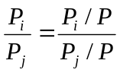.
- Use (I) and part (a) to show that (II) follows from (I).
- Explain why 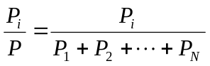.
- Show that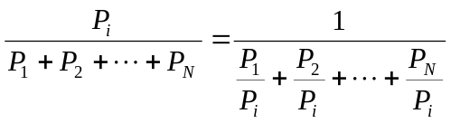.
- Assuming (II) is true, show that 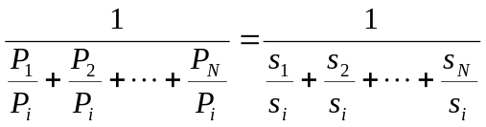.
- Simplify the expression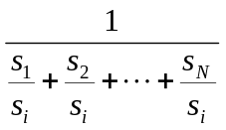.
- Use parts (c) through (f) to explain why (I) follows from (II).

Table 1.7. Seat Allocation Methods

Largest Remainders Methods (LR)

American Designation | European or Math Designation | Quota | Countries
Hamilton (1792)  Vinton Method of 1850 | Hare (1859)  Method of Largest Remainders | P/S | Austria (lower), Belgium (lower), Denmark (higher), Germany (higher)
 | Droop (1868)  Hagenbach-Bischoff | P/(S+1) | Greece (lower)
 | Imperiali | P/(S+2) | Italy (lower)

Divisor Methods (D)

American Designation | European or Math Designation | nth divisor | Sequence of Divisors | Countries
 | Imperiali | (n+1)/2 | 1, 1.5, 2, 2.5, 3 | Belgium (municipal)
Thomas Jefferson (1792) | d’Hondt (1882)  Hagenbach-Bischoff  Greatest Divisors | n | 1, 2, 3, 4, 5 | European Parliament, Belgium (higher), France (1986), Finland, Netherlands
 | Modified Sainte-Laguë | (10 n – 5)/7 | 1, 2.14, 3.57, 5, 6.43 | Denmark, Norway, Sweden
Daniel Webster (1832);  W.F. Willcox (1910);  Owens (1920) | Sainte-Laguë (1910)  Major fractions  Arithmetic mean | 2 n -1 | 1, 3, 5, 7, 9 | Denmark (higher 45-53), Czech Republic, Poland
E.V. Huntington (1920) | Equal proportions  Geometric mean | 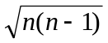 | 0, 1.41, 2.45, 3.46, 4.47 | USA (House of Representatives; adopted in 1941)
 | Danish | 3 n -2 | 1, 4, 7, 10, 13 | Denmark (within parties)
Adams | Smallest Divisors | n-1 | 0, 1, 2, 3, 4 | --
Dean’s Method | Harmonic Mean | 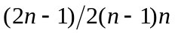 | 0, 1.33, 2.40, 3.43, 4.44 | --

1.5 A Brief History of Democracy

The march of democracy is a “long, hard slog.” While the Magna Carta was promulgated in 1215 AD as a means to curb the powers of King John by his barons, it only became an important document in the great upheavals of mid-17th Century England. It took almost another hundred years from the “democracy of property-owners” which followed the revolt of Oliver Cromwell to the democracy of Parliamentary governments of the late 19th century.

Standard narrative has it that democracy is a pure Western construct which started with 5th-century Athens, then found traces in the “republics” of renaissance Italy, to fully materialize with the American revolution of 1776. This narrative of the history of democracy weeds out the factor of time and influence of environment.

Germs of democracy can be found in various societies throughout history. Traces of “primitive” democracy can be found in Ancient Mesopotamia and among the ancient Israelite tribes. Prehistoric Mesopotamia was organized along democratic lines. Public affairs were handled by elders, while important affairs were brought before the general assembly or Puhrum, which comprised all the citizens of a given town or village. Thus warns the old Babylonian proverb,

Do not stand in the assembly;
Do not stray to the very place of strife;
It is precisely in strife that fate may overtake you;
Besides, you may be made a witness for them.
So that they take you along to testify in a lawsuit not your own.

According to Wolf, the terminology of the Old Testament suggests that originally the entire male population of Ancient Israel constituted the assembly. They always convened “at the gate of the city”, “before the tent” and “at the door of the tabernacle” to debate political and religious matters. Decisions were made by acclamation.

The history of Africa offers similar examples. In his survey of pre-colonial political institutions in Africa over the last 7,000 years, Murdock found “primitive democracy” as “the first and simplest as well as the most widespread type of political system”. In this system, “decisions are reached through discussion and informal consensus.” In Scandinavia, around 800 AD, free men met in allting (common assembly) in the various districts scattered around the country, where they discussed legal and political matters of general concern. During the Middle Ages, these tings, or assemblies, evolved into the local assemblies of rural districts and towns, and they acquired important functions in relations between the king and the common people. It was customary to pledge allegiance to a new king at one of these regional assemblies. The first lagtings (superior regional assemblies) came into existence when Norway united as a kingdom (900 – 1030 AD). These were representative assemblies at which delegates from the various districts in each region met to agree on legal judgments and pass laws. The years 1263 – 1660 were a remarkable period in Scandinavian history. A body of laws was codified (1263 – 80) and applied across the realm until Frederik III, king of the Danish-Norwegian union, declared absolute monarchy in 1660 and codified it as the King’s Act of 1665. This code—which became the constitution of Union of Denmark-Norway until 1814—ended Scandinavia’s early experiment in democracy.

In medieval times representative government had an “occupational character”. The English merchant guild of the early Middle Ages held enormous sway over the government of the boroughs. In the years 1376-1384, the manufacturing guilds of London were able to place representatives in the common council chosen by the crafts guilds. The Lord Mayor of London as well as the four city representatives to Parliament were chosen by members of the livery companies. This was common practice down to the 19th century. In the medieval Italian republic of Florence, beginning in 1293, the Acti, a council of the twenty-one main federations of craft guilds chose the Priors and other ruling magistrates. There is even talk of the “Zunftrevolution” of 1368 when merchants and their followers forced a new constitution (Zunftverfassung) for Strasbourg giving certain guilds direct representation on the City Council. Delegates from twenty-five principal guilds (Zünfte) became part of the City Council and in fact held a majority over the patricians. Many cities across France elected guild members to City Councils. Representation to the Estates systems of medieval times also had an occupational basis. This system was revived by the Soviet Union in the early days of Communism. The parliaments of the late medieval period evolved from the Carolingian assemblies of knights. Matters of general policy and war were discussed by these assemblies with the king acting as a first among equals. The practice continued until the warrior assemblies emerged with the baronial Curia Regis and estate representations. Weber notes:

The basis of democratization is everywhere purely military in character: it lies in the rise of disciplined infantry, the hoplites of antiquity, the guild army of the middle ages…. Military discipline meant the triumph of democracy because the community wished and was compelled to secure cooperation of the non-aristocratic masses and hence put arms, and along with arms political power, in their hands.

Ibn Rushd’s Commentary on the Republic of Plato offers curious textual testimonies on “democracy” within an Islamic setting. The eminent Muslim philosopher and judge considered the application of “Platonic notions—conditioned by Greek concepts and institutions—as fully valid general principles, applicable to Muslim concepts and institutions.” In his discussion of the transformation of the timocratic state into the plutocratic state he writes,

“In general, the transformation of the timocratic into the hedonistic man is obvious, be it that he takes delight in money or in the other remaining pleasures. The same seems to apply to the timocratic and the hedonistic state. For the plutocratic and the hedonistic state belong to the same category. We often see kings becoming corrupted into such like men. Similarly, there is in our time the kingdom of the men known as Almoravids. At first they were imitating the constitution base on the Law… then they changed [it] under his son into the timocratic [constitution] together with an admixture in his of the love of money as well. Further, it changed under his grandson into the hedonistic [constitution] … and perished in his time.”

Rosenthal offers a relevant quote from Ibn Rushd on the propensity of democracy to turn into tyranny on the basis of the Almoravid revolution in the Maghreb:

“You can discern this from the democratic rule that exists in our time, for it frequently changes into tyranny. Take for example the rule existing in our own country, i.e. Cordova, after 500 AH. For it was almost completely democratic, [but] then after 540 AH it turned into tyranny.”
This seems to be the oldest textual reference to a rule by democracy, apart from those from ancient Greek. Rosenthal notes that Ibn Rushd (known in the Europe of the Middle Ages as Averroes) uses timocracy and democracy interchangeably. “The contradiction can be resolved by assuming that ‘democratic’ refers to the Council of the Almoravids as representing the Jamā‘a of Almoravid Islam in the Maghreb.”

According to Muslim Sunni jurists, “an Islamic polity ought to be headed by a non-hereditary, elective sovereign, subject to but not above the law.” This principle led some 19th and 20th century writers to describe the Islamic doctrine of Caliphate as “republican”. A favorite quote on accountability before the people—widely taught to children in the Islamic world—reads: One day, Omar ibn Al-Khattab, the second Caliph of Islam, stood on the pulpit addressing people: “O people! If you find that I have some crookedness, correct me.” One bedouin rose to his feet and said: “By Allah! If we find you crooked, we will correct you with our swords.” Yet Omar, who did not get angry or harbor malice towards him, raised his hands and said: “Praise be to Allah, Who has created among our people a person who is able to correct the crookedness of Omar.”

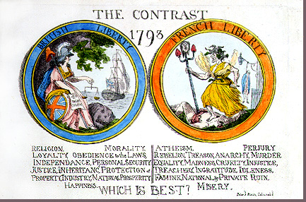

French revolutionaires and those who dumped tea in the Boston Harbor should feel vindicated. Their revolutions against the tyranny of kings have yielded their fruits. Today, no self-respecting state—with claims to democracy—would deny its people the right to say in their affairs through elected representatives. At the heart of the two grand revolutions of the 18th century were issues of taxation and representation. The French supported the rebellion of American colonists and needed new sources of revenue to help in the war. Tax burdens fell on the Third Estate (tiers état, i.e. the mob) with the Second Estate (nobility) paying nearly nothing. After 175 years without meeting, the Estates-General (États-Généraux, medieval French version of Parliament) was called to discuss the matter. The Estates-General voted by estates, with both Clergy (First Estate) and Nobility (Second Estate) outweighing the Third Estate, two to one. Thus the first spark: Third Estate delegates left the Estates-General and declared a ‘National Assembly.’ On the eve of the revolution of 1789, ninety-eight percent of the French were Third Estate—peasants, the working class and the bourgeoisie. It is not strange then that the earliest advocacy of the principle of representation has roots among the French and the Americans.

Among the French the names of the Marquis de Mirabeau, and the mathematicians Jean-Charles de Borda, and the Marquis de Condorcet stand out as the earliest men to concern themselves with electoral problems and practical issues regarding voting and representation. Addressing the French Assemblée Nationale, on the conditions of eligibility to the newly founded institution, wrote Condorcet

“During the convocation of your Assembly, the deputies of the communes were nominated by the electors. However, in assemblies, the confection of records can give birth to parties and give populous eloquence a dangerous influence. In this era, two grand corporations, nobility and the clergy, have become almost completed isolated from the common citizens. These corporations were so little in number if compared with the totality of the inhabitants of the kingdom [of France]. However, they were many when compared with the people they served. … Why should the [Frenchman] be duped further, while elections to assemblies would be better organized, made easy, ..., when he can extend his choice to all the citizens, when his vote— thus far like blowing in the wind—will be guide for the conduct and opinion of those who are in public office... No, Sirs, you have nothing to fear from the legislature. You are now free from all the pecuniary conditions which degraded the dignity of man. The legislature will be as is your Assembly today: The elite of the nation. Enlightened peoples have established pecuniary conditions. However, in England, they are usually eluded, and they were never able to stop corruption. In the United States of America, pecuniary matters are of little importance, since it is easy to acquire property by law... the land is plenty... Thus, the inequality engendered by pecuniary conditions in England or America, are only sensed when close to elections... Moreover, in England, as well as in the United States, electors have no functional means to make choices solely on the basis of the public
conduct of the candidates.”

In his “ce que les citoyens ont droit d'attendre de leurs réprésentans,” [“What Citizens Should Expect from their Representatives”], he writes

“In America, and even in England, one can say that individuals have civil rights. However, when it comes to political rights, they have none. In England, the principle of ‘sovereignty of the people’ is upheld. But, there is no mechanism to exercise it.”

In the words of Mirabeau (quoted in de Grazia, p. 47),

“[The] Assembly for a nation is nothing but a reduced map of its physical extent: whether small or large, the copy should always have the same proportions as the original.”

The earliest mathematical derivation of an election system seems to be Jean-Charles de Borda’s “Mémoire sur les Elections du Scrutin” in 1781. De Borda (1733-1799), who later served in the French National Assembly, got interested in election schemes ten years earlier (see de Grazia). In 1770, he suggested to the French Academy that in an election by ballot between more than two candidates, the one who obtains the majority of the votes is not necessarily he whom the electors prefer to his competitors (Hart). His contribution was part of a popular trend among French mathematicians of the Enlightenment—such as Condorcet (who was elected to the French Academy of Sciences in 1769) and Laplace (1749-1823)—to produce “practical and usable knowledge”. Hoag & Hallett (1926) attribute the earliest record of a proportional system mathematical paper to another French mathematician by the name of Gergonne. However, his paper Arithmétique politique: Sur les élections et le système représentatif dates from 1820, and he suggested no specific method of implementation of his ideas. The first application of an actual proportional voting scheme at the level of a Society was done by English schoolmaster Thomas Wright Hill, father of Rowland Hill—the founder of the modern postal system, in 1821. His son Rowland was the first to apply it in the public sphere in Adelaide, South Australia, in 1839. He was then Secretary of the Colonization Commission of South Australia. According to Hart, Hill applied a version of Gergonne’s scheme rather than his father’s (p. 7).

In 1857, Thomas Hare, an inspector of charities published a 53-page pamphlet entitled The Machinery of Representation. In it, he advocated a new system of single transferable vote (STV). Hare devised his system after he saw the defeat of several prominent Liberal and Radical politicians who criticized the Crimean War, Palmerston’s bigotry, and ‘vengeance upon China’ (Hart, p. 26; Bromund). Hare’s pamphlet received much attention and went into second edition the same year. The pamphlet was enthusiastically expanded to a 370-pages long book entitled A Treatise on the Election of Representatives, Parliamentary and Municipal in January 1859. Hare’s book received much admiration from John Stuart Mill. Hare appeared “to have exactly, and for the first time, solved the difficulty of popular representation; and by doing so, to have raised up the cloud and gloom of uncertainty which hung over the future of representative government and therefore of civilisation.” (quoted in Hart, p. 38). Hare’s book inspired Mill “with new and more sanguine hopes respecting the prospects of human society.” (J.S. Mill, Autobiography). Hare had troubles with some aspects of his scheme. They were pointed out in 1868 by H.R. Droop, a British mathematician and lawyer. It was the correction by Droop that was been adopted by proportional representation advocates in latter years.

Hare’s scheme was received favorably on the Continent, but not much reception in England. It was discussed in Amsterdam in 1864 in a congress for the Progress of Social Sciences. A French newspaper publicized it. In fact, it was already in the stage of implementation on a national level in Denmark since 1855. The system was independently invited and introduced by Carl Christopher Georg Andrea, a mathematician and geodesist, then a Minister of Finance (Hoag & Hallett, Hart). In April, 1870, the Hare system of preferential voting was introduced by the Alumni of Harvard University for the nomination of Overseers of the College. The Proportional Representation Society (P.R.S.) was founded in January 1884 by Sir John Lubbock, a charismatic banker, naturalist and political economist. Lubbock hoped proportional representation would quell popular discontent. According to Bromund,

The leaders of the P.R.S. believed that proportional representation would help unify the nation and the empire by preventing Westminster from being dominated by organized parties, by allowing voluntary association of interests the fullest play, and by giving electors reasons to care about politics… The leaders of the P.R.S. believed the evils that would arise from unchecked democracy were foreshadowed in America, which contemporary commentators accepted was subject to levelling tendencies far more pronounced than those in Britain.

The list type of proportional representation was first introduced by Victor Considérant, a disciple of Fourier in 1834. Other names associated with the invention of this scheme are Thomas Gilpin of Philadelphia who published his pamphlet in 1844 and Swiss writer Antoine Morin who published a book on the list system in 1861. The year 1881 saw the birth, in Belgium—known then for divisions between Flanders and French, Catholics and Socialists, of the Association Reformiste pour l’Adoption de la Representation Proportionelle. A key founder was Victor d’Hondt (1841-1901) a professor of civil law at Ghent University. He formulated a new system of proportional representation the following year. In the summer of 1885, a major conference on Proportional Representation was convened in Antwerp. Delegates from key West European countries attended: Switzerland, France, Belgium, Italy, Germany, Holland and Denmark. A paper by Thomas Hare was read in his absence though none from the Proportional Representation Society of England attended. Later, a resolution adopted three key elements was passed. It rejected systems based on absolute majorities. It adopted ‘proportional representation [as] the only means of assuring power to the real majority of the country, an effective voice of minorities, and exact representation to all significant groups of the electorate.’ It also chose the d’Hondt “system of competing lists with divisors”. An electoral injustice in the Swiss canton of Ticino led the federal government to introduce proportional representation in 1889. Belgium and Serbia adopted it in 1899. Many other countries followed suit: Finland (1906), Cuba (1908), Sweden (1909), Portugal (1911), Bulgaria (1911). The adoption of proportional representation by Ireland in 1920 was achieved thanks to efforts by the Proportional Representation Society which sent Lord Courtney in 1911. He advocated PR as a solution to the home rule problem. It guaranteed representation for the Protestant minority (Carstairs). Thanks to the single-handed work of Catherine Helen Spence of Adelaide, Tasmania became the first English-speaking community to adopt PR in the Hare scheme of single transferable vote for public elections in 1896. In addition to John Stuart Mill, Alexis de Tocqueville, Henri Poincaré, and Lewis Carroll were among the prominent figures who lend support for PR.

Figure: Boston Tea Party

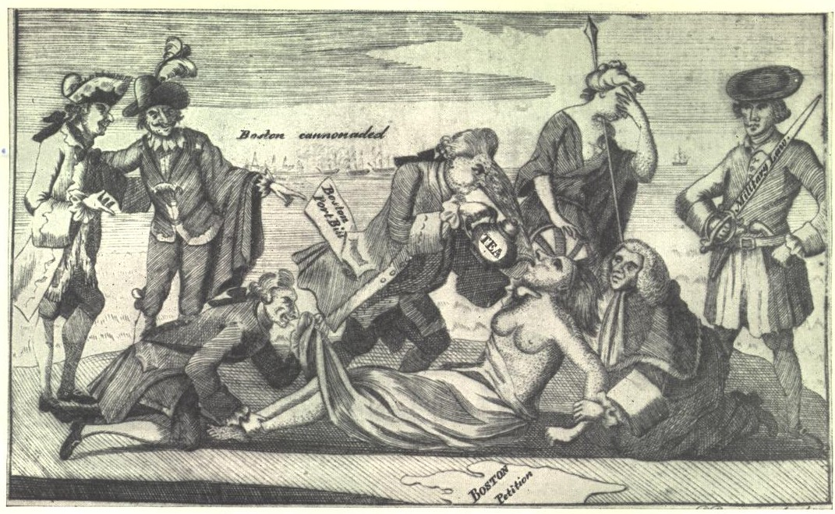

While the French might have understood and theorized what constitutes ‘democracy’ one should emphasize that ‘democracy’ as a modern concept and practice is a true child of the ‘Land Beyond the Pillars of Hercules.”

Political mythology has it that The Fundamental Orders of Connecticut, adopted by the citizens of Hartford and neighboring towns on January 14, 1638, were the "first written constitution of a modern democracy." However, the commonwealths of the Puritans of yore were amalgams of theocracy, fierce individualism, and democracy. When the settlements at Portsmouth and Newport were united in 1641 they were declared to be

a democracy or popular government; i.e. it is in the power of the body of freemen orderly assembled, or the major part of them, to make or constitute just laws… and to depute from among
themselves such ministers as shall see them faithfully executed.

Democracy did not extend to the natives, and attitudes towards French ways were not all favorable.

“Racial pride or prejudice had prevented any fraternization between the English settlers and the savages… The English were fundamentally farmers and home-builders… [T]he native for the English was neither business partner nor a military ally. He was, for the most part, a dangerous animal, like the panthers, wolves and wild-cats, or a nuisance like the stones and tree stumps, to be cleared away before advancing settlements. The French on the other hand, had no racial antipathy. They became brothers of the savages, lived with them and took Indian mistresses or wives. They were traders, adventurers, explorers, not settlers… The war begun in Europe in 1689 between two civilized nation was almost immediately echoed back from the American forests by the warwhoop of the savages. With much cruelty, parties of French and Indians fell on our settlements…”

Democracy rose in the pre-modern world as a reaction to ‘aristocracy’ and monarchial tyranny. Democracy was theoretical among the French who accepted the notion of the tyranny of the revolution. Among the Americans, Hamilton detested the French revolution and its ‘egalitarian’ creed.

“The French Revolution had broken out in 1789, and at first we all followed its course with enthusiasm. It was easy to get drunk on abstract liberty in the eighteenth century, and the French people seemed to be following in our footsteps. Washington had been in office but a few weeks in his second term when news arrived that caused a revulsion of sentiment among a large part of the Americans. The increasing bloodshed and the brutal violence of the French movement had culminated in cutting off the head of the King after the Declaration of a Republic, and France had declared war on England and Spain… These events killed the sympathy of many Americans…”

Of American democracy, we find the critical note of John Stuart Mill,

“The natural tendency of representative government, as of modern civilization, is towards collective mediocrity… In the false democracy which, instead of giving representation to all, gives it only to the local majorities, the voice of the instructed minority may have no organs at all in the representative body. It is an admitted fact that in the American democracy, which is constructed on this faulty model, the highly-cultivated members of the community, except such of them as are willing to sacrifice their own opinions and modes of judgement [sic], and become the servile mouthpieces of their inferiors in knowledge, seldom even offer themselves for Congress or the State Legislature, so little likelihood have they of being returned. Had a plan like Mr. Hare’s by good fortune suggested itself to the enlightened and patriotic founders of the American Republic, the Federal and State Assemblies would have contained many of these distinguished men, and democracy would have been spared its greatest reproach and one of its most formidable evils.”

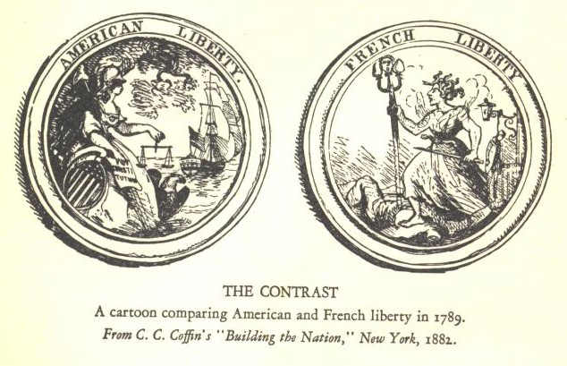

Balinski and Young insist—not without merit—that all the methods of apportionment devised in Europe have some roots in the political history of the United States. The democratic ideal is enshrined in the U.S. Constitution. According to Article 1, Section 2,

“Representatives and direct Taxes shall be apportioned among the several States which may be included within this Union, according to their respective Numbers, which shall be determined by adding to the whole Number of free Persons, including those bound to Service for a Term of Years, and excluding Indians not taxed, three fifths of all other persons. …

The Number of Representatives shall not exceed one for every thirty thousand, but each State shall have at least one Representative;”

The history of PR in Germany offers a vivid example of how democracy can give birth to its antithesis. It also offers a commentary on the limits of what constitutes “mathematical justice”. It was during the “Weimar Republic” and through the ballot-boxes that Hitler and his Social Nationalists came to power in the mid-1930s. Japan’s “Taisho democracy” of the mid-1920s gave rise to an era of mass politics which was used by the Japanese army to sell an imperial ideology with wide appeal. There is a strong correlation between democratization and the rise of belligerent nationalism and war.

Patterns of Democracy: Government Forms and Performance in Thirty-Six Countries, Arend Lijphart, Yale University Press, New Haven, 1999.
See “Electoral formulas: A macroscopic perspective,” A. Blais & L. Massicotte, European Journal of Political Science 32: 107-109, 1997.
Polis is Greek for ‘city’. Compare with the Latin ‘Civitas’ and Arabic ‘Medina’. The "barbarians" of the Greeks (lit. the 'foreigners') dwelt "outside" the Polis and did not participate in its affairs.
See The Muqaddimah, in Franz Rosenthal’s translation, vol. I, Pantheon Books, New York, 1958.
Democracy in the United States, William Riker, Macmillan, 2nd Edition, 1965.
“Religion and the Third Wave,” Samuel Huntington, National Interest 24, 29-42.
The third wave: democratization in the late twentieth century, Samuel Huntington, University of Oklahoma Press, Norman, 1991, p. 9.
For a detailed description of all subsystems see “Electoral System Families” at the IDEA website http://www.idea.int/esd/systems.cfm. For a list of countries subscribing to a particular system see “The Electoral Systems of Independent States and Related Territories Worldwide” at http://www.idea.int/esd/data/world.cfm.
For example, 119 of 192 countries are classified in a study conducted by Freedom House in 1999 as “electoral democracies”. “…[L]iberal democracies—i.e. countries Freedom House regards as free and respectful of basic human rights and the rule of law—are 85 in number and represent 38 percent of the global population.” See, Democracy’s Century: A survey of global political change in the 20th century, Freedom House, December 7, 1999, www.freedomhouse.org/reports/century.html.
For example, Algeria, Morocco and Madagascar adopted PR, Niger and Tunisia adopted semi-PR forms, Djibouti and Gabon chose plurality, while Mali and Mauritania still use majority. All were French colonies which gained independences in the late fifties and early sixties.
See Exercise 7 in which women’s participation rates under each system are computed.
In the 2000 census, there were 35,305,818 Hispanics in the U.S., 16,907,852 of whom identify as “white”; 710,353 are “black or African American”, 14,891,303 are “some other race”, and 2,224,082 have “two or more races”. (US Census Bureau Release, April 1, 2000)
Women’s Underrepresentation and Electoral Systems, Wilma Rule, PS: Political Science and Politics, Vol. 27, No. 4 (1994), 689-692.
The International IDEA Handbook of Electoral System Design, Reynolds, Andrew; Reilly, Ben, The International Institute for Democracy and Electoral Assistance (IDEA), www.idea.int, Stockholm, 2002 Reprint, p. 30.
from data collected by the Inter-Parliamentary Union in 181 countries;
Women in National Parliaments website, www.ipu.org/wmn-e/world.htm.
See http://www.stortinget.no/english/history.html.
See http://www.sofia.mfa.no/Norway/Norway+at+a+glance/Norway+at+a+glance.htm.
See “Florida List for Purge of Voters Proves Flawed”, New York Times, 10 July 2004. http://www.nytimes.com/2004/07/10/national/10florida.html.
See “A Fair Voting System for South Africa” at http://www.fairvote.org/reports/1993/reynolds.html.
Comparing Proportional Representation Electoral System: Quotas, Thresholds, Paradoxes and Majorities, M. Gallagher, British Journal of Political Science, 22:4 (1992), 469-496.
Exercise 14 shows that these conditions are equivalent.
See Exercise 13.
Antigua & Barbuda uses a “First Past the Post” (FPTP) system to decide who gets elected. This is a plurality system and a legacy from British colonial times.
The alternatives were produced using various forms of proportional representation which will be described in chapters 2 and 3.
The Excel file works for any number of seats, up to 300 parties.
Data provided by Psephos Election Archive, http://psephos.adam-carr.net/countries/a/antigua/. Like most English speaking Caribbean countries, Antigua & Barbuda inherited the First-Past-The-Post (FPTP) system from Britain. The seat distribution displayed is that determined by this system. The alternatives were produced using PR.
Data also provided by Psephos Election Archive, http://psephos.adam-carr.net/countries/p/pakistan/
Data from Psephos Election Archive, http://psephos.adam-carr.net/countries/p/pakistan/
Democracy, from the Greek demos = people, kratos = rule. It is interesting to note that the literal meaning of kratos is town. This is why in the Middle Ages, Arab translations of Greek classics chose “medina jamiyah” for “democracy”; aristocracy was called “medina imamiyah”. The word “kratos” is still found in both Arabic and Hebrew under the meaning of “village” in the forms “Karyah” and “Kiryat” and can still be traced in the name of Carthage (Kart Hadasht=New City).
This expression was recently revived by U.S. Secretary of Defense Donald Rumsfeld who also appears on the board of directors of Freedom House.
Historians note that William Shakespeare failed to mention the Magna Carta in his historical play King John.
See the BBC:http://www.bbc.co.uk/history/timelines/england/stu_world_upside_down.shtml.
See for example the two volumes edited by Seymour Lipset, Democracy in Europe and the Americas, Democracy in Asia and Africa, Congressional Quarterly, Inc., Washington, D.C., 1998.
“Communal Democracy and its History”, A. Black, Political Studies, Vol. XVI (1997), 5-20.
“Primitive Democracy in Ancient Mesopotamia”, T. Jacobsen, Journal of Near Eastern Studies, Vol. 2, No. 3 (Jul. 1943), 159-172.
“Traces of Primitive Democracy in Ancient Israel”, C. Umhau Wolf, Journal of Near Eastern Studies, Vol. 6, No. 2. (Apr., 1947), pp. 98-108.
Puhrum seems to be an ancient ancestor of a public “forum”.
T. Jacobsen, opt. cit., notes the parallels between prehistoric Mesopotamia and the “primitive Teutonic tribes who overrun Western Europe”. W. J. Shepard calls “primitive democracy” a “rude form of democracy in which government was not differentiated no law clearly distinguished from religious or social custom.”
Their “amen” was a “primitive” form of the English “ye” and “nay”.
Quoted in “Domesticating Democracy: Culture, Civil Society, and Constitutionalism in Africa”, Maxwell Owusu, Comparative Studies in Society and History, Vol. 39, No. 1 (Jan. 1997), 120-152. Owusu notes that “Members of African societies sense their unity and perceive their common interests in symbols in the form of myths, proverbs, fiction, dogmas, ritual, sacred places and persons, and so forth; it is their attachment to these symbols which gives African societies their identity, cohesion and persistence. Some of these powerful symbols could be adapted to serve modern democratic governance…”
“From local assembly to national assembly,” History of Norway’s Storting, www.stortinget.no/english/history.html
“Occupational Versus Proportional Representation”, Paul H. Douglas, The American Journal of Sociology, Vol. 29 (1923), 129-157.
See ``The Guilds of Early Modern Augsburg'' by E. L Skip Knox; http://oit.boisestate.edu/sknox/dissertation/
Curia Regis is Latin for “Royal Council”.
“Medieval Origins of Constitutional Government in the West”, Brian M. Downing, Theory and Society, Vol. 18, No. 2 (Mar. 1989), 213-247.
Quoted in Downing, opt. cit.
“The place of politics in the philosophy of Ibn Rushd,” Erwin I. J. Rosenthal, Bulletin of the School of Oriental and African Studies, University of London, Vol. 15, No. 2 (1953), 246-278.
timocratic=rule by honor and military glory; from the Greek tīmē, value, honor + kratia, cracy; compare with the Arabic dhimmah, also honor.
plutocratia=rule by the wealthy.
The period corresponds to the years 1106-1145 AD. Almoravids, were Berber Moors who invaded the bulk of the Maghreb and Andalusia and controlled much of both from 1056 – 1147 AD.
“Jama`a” (lit. “the community”) stands for “Jamaat al-Muslimeen”, the Muslim populace as a whole.
See “Djumhuriyya”, in Encyclopedia of Islam, New Edition, Vol. II, E. J. Brill, 1965, 594-597.
“Republic” seems to have been the choice for the bulk of systems in the Islamic world. The word “jumhuriyah”, coined in the late 18th century by Ottoman scholars, derives from the Arabic “jumhur”, meaning mass or people. The respected British Lexicographer and Orientalist G. P. Badger chose “Hukm Jumhuri” as a translation of the word “democracy” in his An English-Arabic Lexicon (Reprinted by Librairie du Liban, Beirut, 1967). He translates “republic” as “Hukumah Jumhuriyah”, and explains “[this is] a commonwealth, [a] government by the election of the citizens”, pp. 223, 875.
French Revolution Research Collection, Oeuvres de Condorcet, publiées par A. Condorcet O'Connor et M. F. Arago, Tome Dixième, Paris, Firmin Didot Frères, 1847, pp. 84, accessed via gallica.bnf.fr
gallica.bnf.fr
Borda’s paper was translated into English by Alfred de Grazia. See “Mathematical Derivation of an Election System”, ISIS, Vol. 44 (1953), pp. 42-51.
A Short History of Electoral Systems in Western Europe, A. M. Carstairs, George Allen & Unwin, London, 1980.
Originally a “democrat” was one of the republicans of the French revolution. In the U.S., a democrat was an anti-federalist, or one who carried on the beliefs and practices of Thomas Jefferson. In the popular slang of 1890, a “democrat” is a “high four-wheeled cart, painted and varnished, with double seats, one behind the other.” See, The Oxford English Dictionary, 2nd Edition, Clarendon Press, Oxford, 1989, Vol. II.
The pillars of Hercules are a reference to the Strait of Gibraltar from Greek Mythology, and a reference to the perils of travels in the Mare Tenebrosum (The Atlantic Sea); the pillars appear today as the double bar of the dollar sign. See http://www.saudiaramcoworld.com/issue/199203/pillars.of.hercules.sea.of.darkness.htm.
The third wave : democratization in the late twentieth century, Samuel Huntington, University of Oklahoma Press, Norman, 1991.
Quoted in, “The Political Ideas of the Puritans, II”, Herbert L. Osgood, Political Science Quarterly, Vol. 6, No. 2 (Jun., 1891), 201-231.
The March of Democracy, James T. Adams, Vol. I, Scribner’s, New York, 1932, p. 44.
The March of Democracy, opt. cit., p. 178
On Liberty, Representative Government and the Subjection of Women, J. S. Mill, Oxford University Press, London, 1912 edition, 259-260.
After the city of Weimar.
“Democratization and the Danger of War”, E. D. Mansfield and J. Snyder, International Security, Vol. 20, No. 1 (Summer, 1995), 5-38.

